Project Planning Phase
Project Planning Template (Product Backlog, Sprint Planning, Stories, Story points)
Date | 01 October 2026
Team ID | [Enter your Team ID]
Project Name | Blog Nest – AI-Powered Blogging & Content Management Backend
Maximum Marks | 5 Marks

Product Backlog, Sprint Schedule, and Estimation (4 Marks)
Product backlog and sprint schedule for Blog Nest (4 sprints × 20 story points = 80 story points).
Sprint | Functional Requirement (Epic) | User Story Number | User Story / Task | Story Points | Priority | Team Members
Sprint-1 | Setup & Authentication | USN-1 | As a user, I can register with name, email and password. | 3 | High | [Team Member]
Sprint-1 |  | USN-2 | As a user, I can log in and receive a JWT token. | 3 | High | [Team Member]
Sprint-1 |  | USN-3 | As a user, my password is stored as a bcrypt hash. | 2 | High | [Team Member]
Sprint-1 | Role-Based Access | USN-4 | As an admin, I can assign roles; routes are guarded by role (Admin/Editor/Author/Reader). | 5 | High | [Team Member]
Sprint-1 |  | USN-5 | As an admin, I can manage user accounts. | 3 | High | [Team Member]
Sprint-1 | Project Setup | USN-6 | Set up Node/Express project, MVC folders and MongoDB connection. | 2 | High | [Team Member]
Sprint-1 |  | USN-7 | Add centralized error handling and logging. | 2 | Medium | [Team Member]
Sprint-2 | Blog Management | USN-8 | As an author, I can create a post (draft/scheduled/published). | 3 | High | [Team Member]
Sprint-2 |  | USN-9 | As an author, I can edit and delete my own posts. | 3 | High | [Team Member]
Sprint-2 |  | USN-10 | Manage post status transitions (draft, scheduled, published). | 3 | High | [Team Member]
Sprint-2 | Public Access & Search | USN-11 | As a reader, I can browse published posts without login. | 2 | High | [Team Member]
Sprint-2 | Categories & Tags | USN-12 | As an author/editor, I can manage categories. | 3 | Medium | [Team Member]
Sprint-2 |  | USN-13 | As an author, I can tag posts. | 2 | Medium | [Team Member]
Sprint-2 | Search | USN-14 | As a reader, I can search by keyword, category and tag. | 3 | Medium | [Team Member]
Sprint-2 | Media | USN-15 | Store media metadata and asset paths for posts. | 1 | Low | [Team Member]
Sprint-3 | Comments & Moderation | USN-16 | As a reader, I can comment on a published post. | 2 | Medium | [Team Member]
Sprint-3 |  | USN-17 | As an editor/admin, I can mark comments approved, pending or spam. | 3 | High | [Team Member]
Sprint-3 |  | USN-18 | As an editor, I can review pending posts and update status. | 3 | High | [Team Member]
Sprint-3 | AI Features | USN-19 | As an author, I can generate a blog from a topic using Gemini. | 5 | High | [Team Member]
Sprint-3 |  | USN-20 | As an author, I can get an AI summary of an article. | 4 | High | [Team Member]
Sprint-3 |  | USN-21 | Configure Gemini SDK, API key handling and prompt templates. | 3 | High | [Team Member]
Sprint-4 | Security Hardening | USN-22 | Add sanitization against XSS and NoSQL injection. | 3 | High | [Team Member]
Sprint-4 |  | USN-23 | Add rate limiting on sensitive routes. | 3 | High | [Team Member]
Sprint-4 | Testing | USN-24 | Test all endpoints in Postman (positive and negative cases). | 5 | High | [Team Member]
Sprint-4 |  | USN-25 | Fix identified bugs and retest. | 3 | High | [Team Member]
Sprint-4 | Delivery | USN-26 | Record demo and API-testing videos. | 3 | Medium | [Team Member]
Sprint-4 |  | USN-27 | Prepare project documentation and report. | 3 | Medium | [Team Member]
Project Tracker, Velocity & Burndown Chart: (4 Marks)
Sprint | Total Story Points | Duration | Sprint Start Date | Sprint End Date (Planned) | Story Points Completed (as on Planned End Date) | Sprint Release Date (Actual)
Sprint-1 | 20 | 6 Days | 03 Aug 2026 | 08 Aug 2026 | 20 | 08 Aug 2026
Sprint-2 | 20 | 6 Days | 10 Aug 2026 | 15 Aug 2026 | 20 | 15 Aug 2026
Sprint-3 | 20 | 6 Days | 17 Aug 2026 | 22 Aug 2026 | 20 | 22 Aug 2026
Sprint-4 | 20 | 6 Days | 24 Aug 2026 | 29 Aug 2026 | 20 | 29 Aug 2026
Velocity:
Each sprint lasts 6 days and the team completed 20 story points per sprint, so the team velocity is 20 points per sprint.
Average Velocity (AV) = Sprint Velocity / Sprint Duration = 20 / 6 ≈ 3.33 story points per day.
Burndown Chart:
The burndown chart compares the work remaining (story points) with time. The actual line stays close to the ideal line, showing steady delivery across all four sprints.
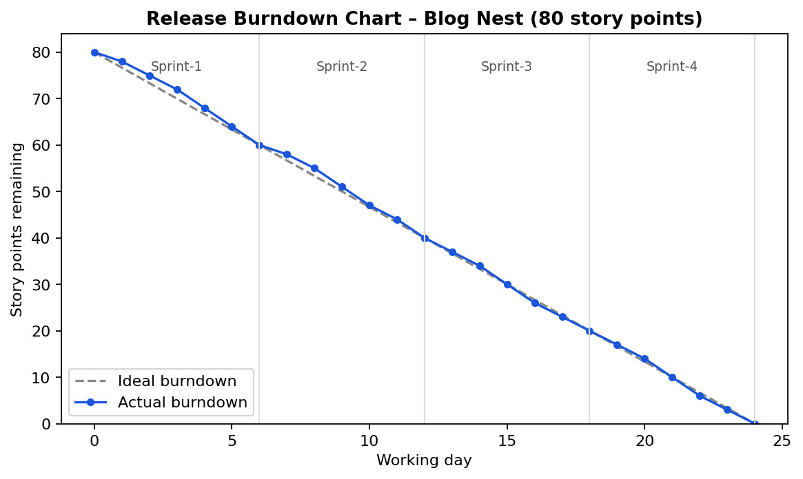
Figure 1: Release burndown chart (80 story points over 24 working days)

